**Indian Institute of Technology, Indore**

User Manual

**Online Administration Portal**

**Administration Department, IIT Indore**

**CS-208 Group-I**

**Guide: Dr. Abhishek Srivastava**

Contents

# Overview

1. **Login**
2. **User Tasks**
   1. **Inbox**
   2. **Outbox**
   3. **Trashbox**
   4. **Profile**
   5. **Service Book**
   6. **Leave Account**
   7. **LTC Record**
   8. **LTC Declaration**
   9. **Service Register**
3. **Admin Tasks**
   1. **Admin Panel**
      * 1. **Register**
        2. **All user details**
        3. **Update user details**
4. **Logout**

1. Overview

This document contains instructions for using the “Online Administration Portal” for administration department of Indian Institute of Technology, Indore as a part of an academic project by CS208 Group 1.

2. Login

Follow the given steps to login to the system:

1. Go to the following link: localhost/OAP/login.php

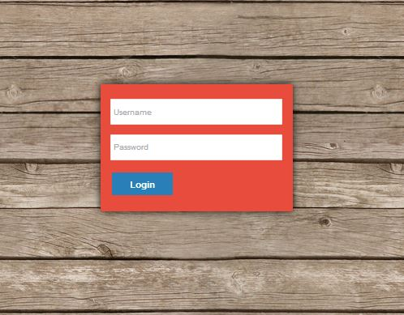

1. Enter your username and password
2. If the username and password is correct it will redirect you to the portal

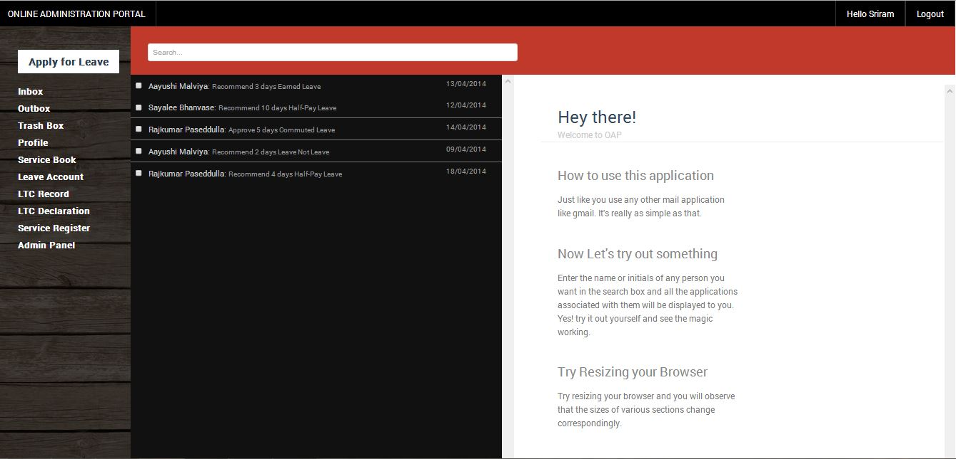

1. Else you’ll be asked to enter the username and password again

3. User tasks

3.1 Inbox

* 1. Inbox contains all the leaves that other users sent to you for approval/recommendation. The leaves can be selected from the list and are then displayed in the box at the right.

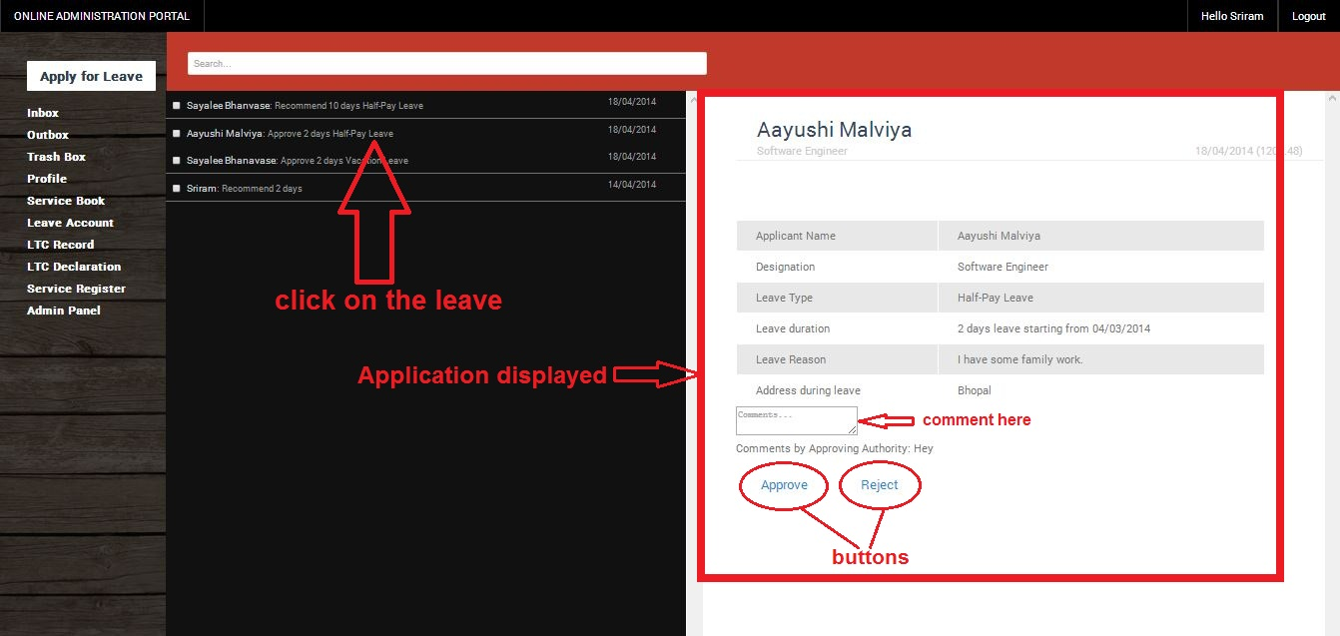

* 1. The details entered by the user are displayed in the application
  2. The leaves can be rejected/recommended/approved using the “Approve”/”Reject”/”Recommend” buttons
  3. Also, you can add your comment in the leave, if you wish, using the comment box
  4. After the application is approved/recommended/rejected, a dialog box appears on the screen informing about the successful approval/recommendation/rejection of leave

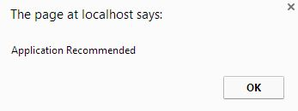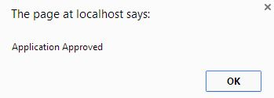

* 1. In case of failure, it displays a failure message in the dialog box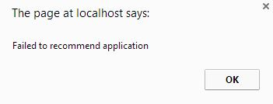
  2. You can search for all leaves sent to you for approval/recommendation by any user by typing his/her name in the search box. 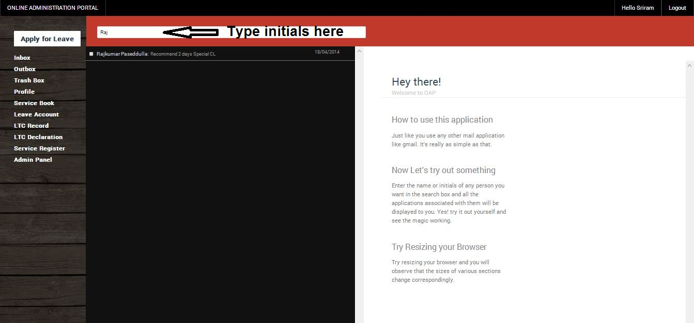

3.2. Outbox

* 1. Outbox contains all the leaves that you sent to other users for approval/recommendation. The leaves can be selected from the list and are then displayed in the box at the right.

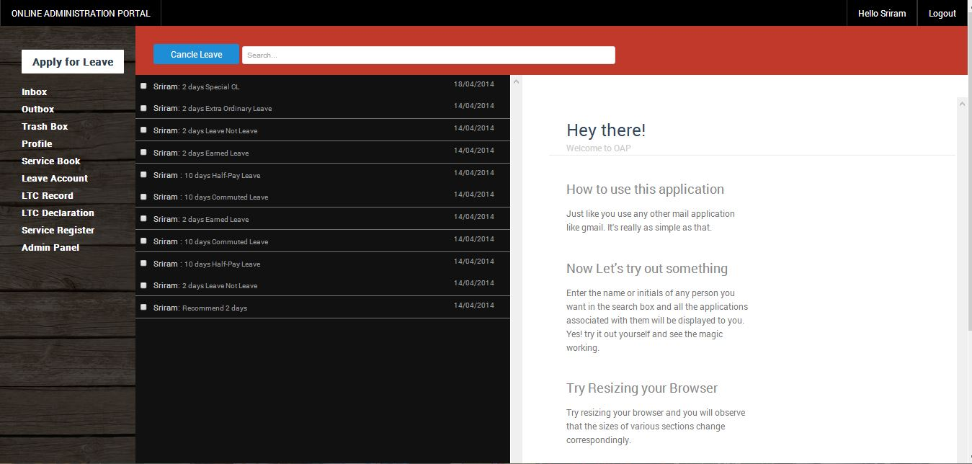

* 1. The details entered by you at the time of submission are displayed in the application.
  2. You can commute the half-pay leaves using the “Commute leave” button given at the top-left hand corner of the application. Only half-pay leaves can be commuted.

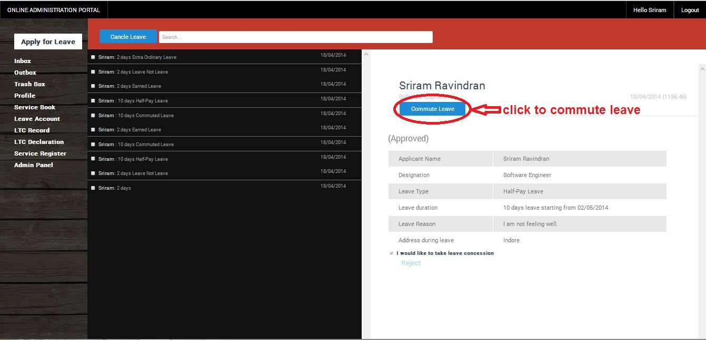

* 1. You can also cancel multiple leaves at the same time by checking the checkboxes in the list and then clicking the “Cancel Leave” button near the search box.

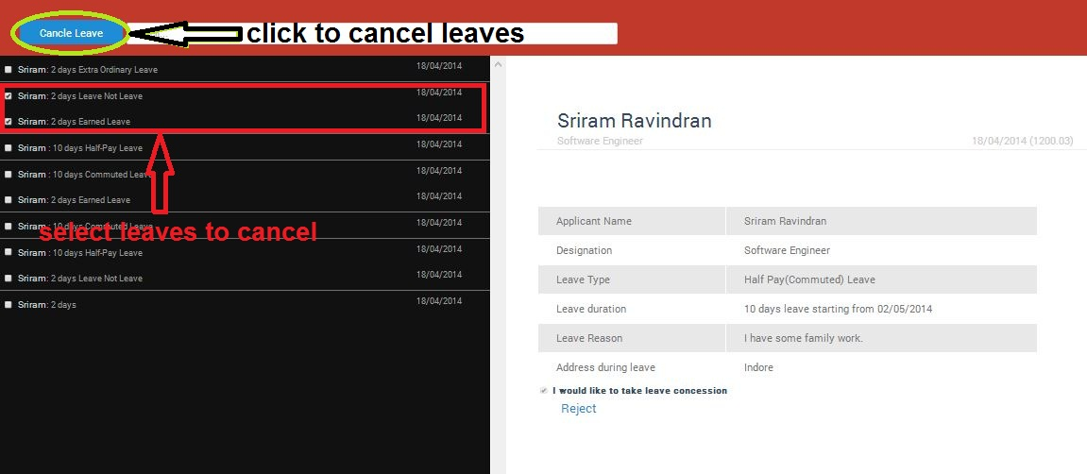

3.3. Trashbox

* 1. Trashbox contains all the leaves that you cancelled. The leaves can be selected from the list and are then displayed in the box at the right
  2. The details entered by you at the time of submission are displayed in the application
  3. These leave applications can’t be restored

3.4. Profile

The Profile page displays all the information as contained in the first page of the service book.

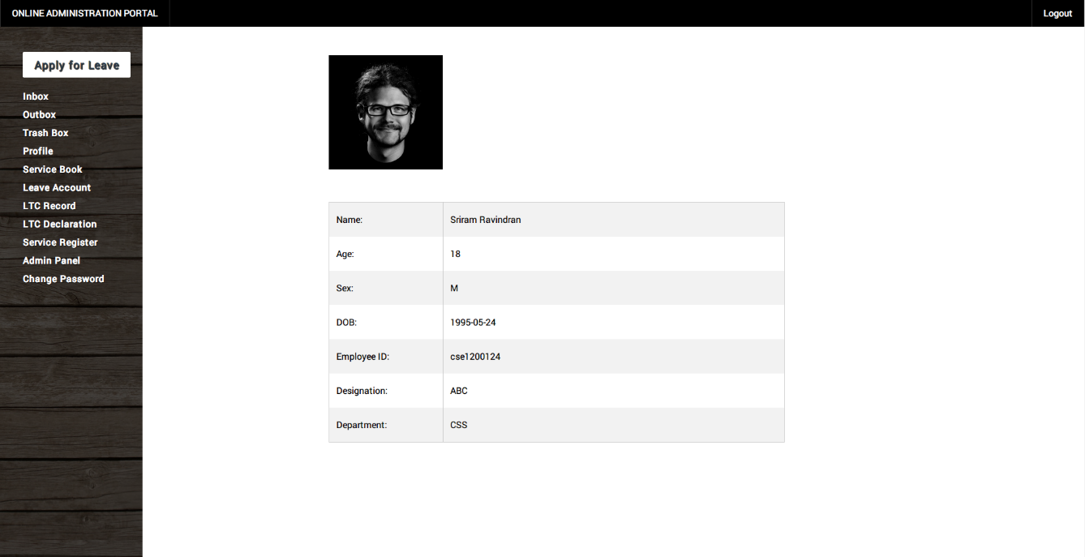

3.5. Service Book

* **Part I : Biodata**

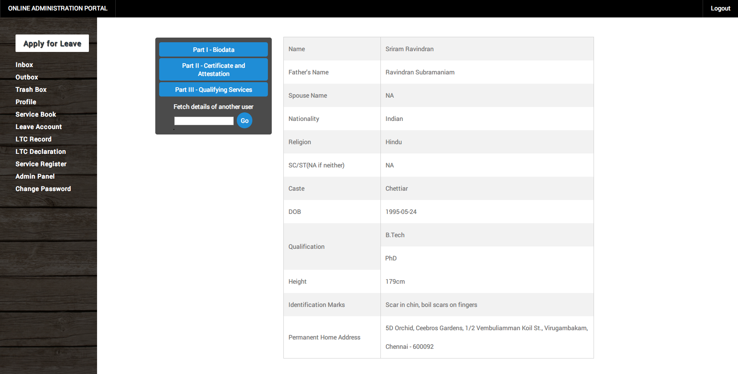

* **Part II : Certification and Attestation**

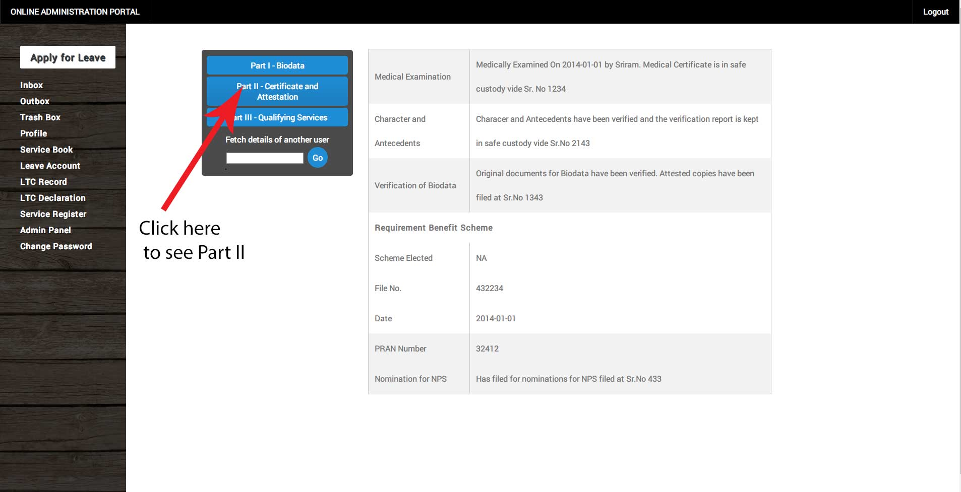

* **Part III : Previous qualifying Services & Foreign Services**

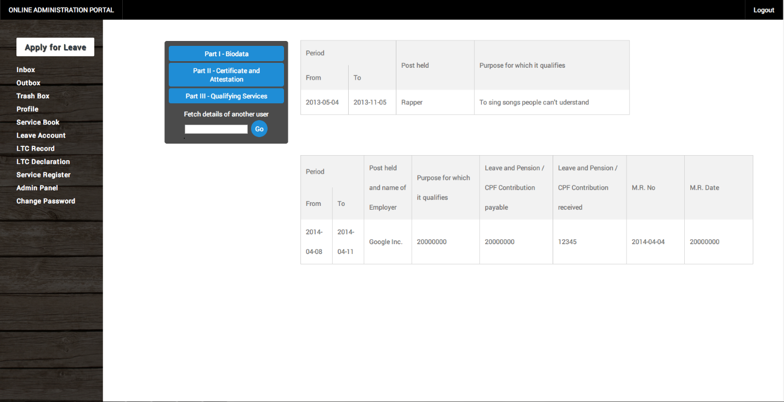

* **For admins**: You alone will be able to fetch details of another user. Normal users won’t get the option. Just type the Employee number to fetch that persons details.

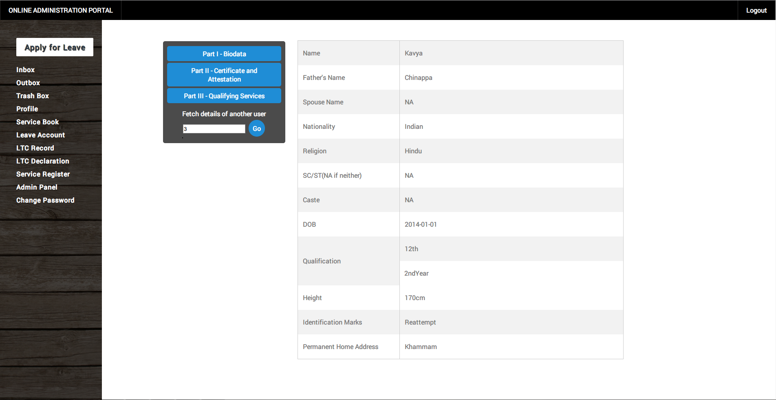

3.6. Leave Account

* 1. It’s a record of all the past leaves that you have taken.
  2. There are three tabs in this:
* Leave Balance: Displays the credit for all leave types

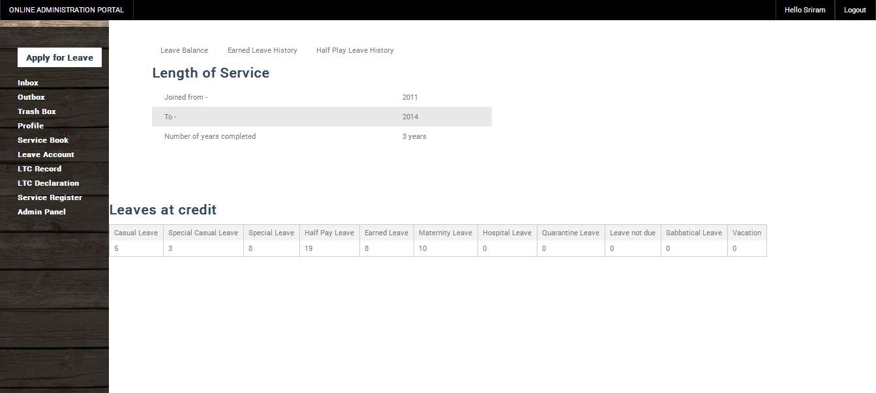

* Earned Leave History: Displays the history for the earned leaves and some other details.

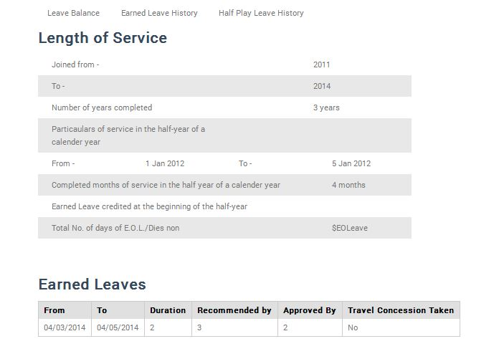

* Half-Pay Leave History: Contains three tabs:
  + Half-pay leaves
* Commuted leaves
* Leaves not due
* By selecting these tabs, all leaves of that type which are applied till date will be shown in a table as shown here.

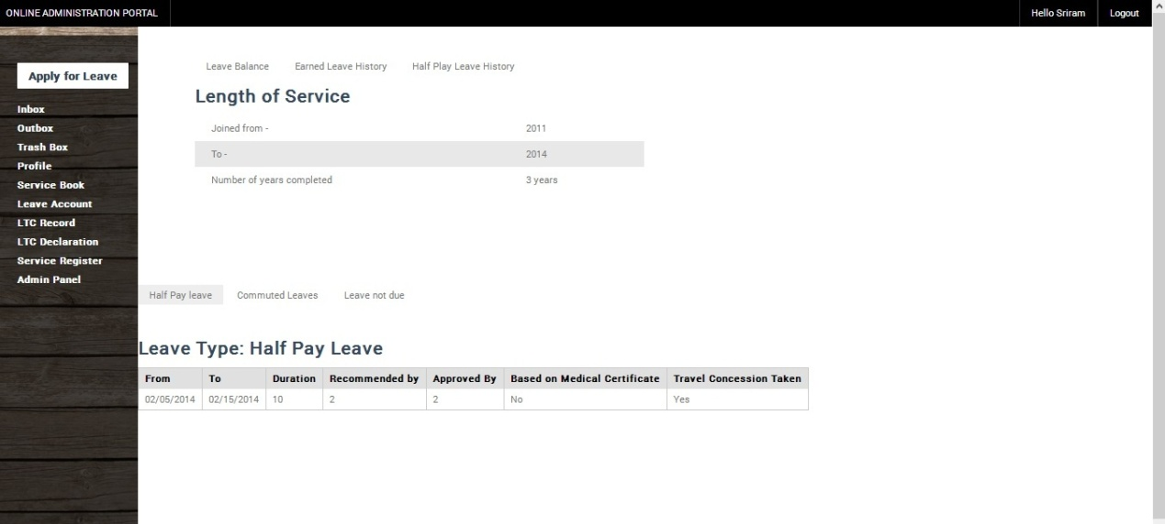

3.7. LTC Record

* 1. LTC Record contains the details of all the LTCs that you’ve taken in the past

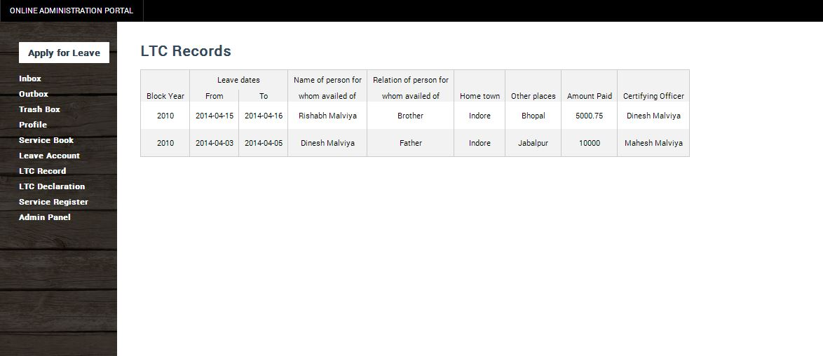

3.8. LTC Declaration

LTC Declaration contains the details as specified in Service book Pg. 61.

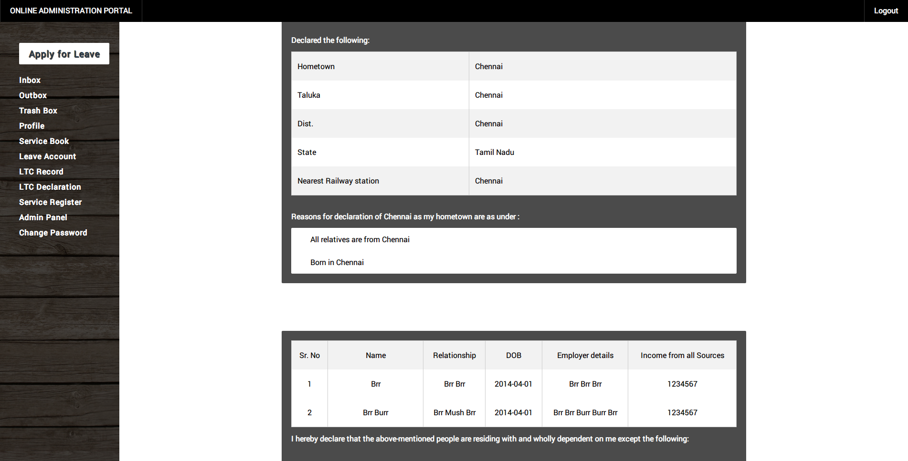

3.9. Service Register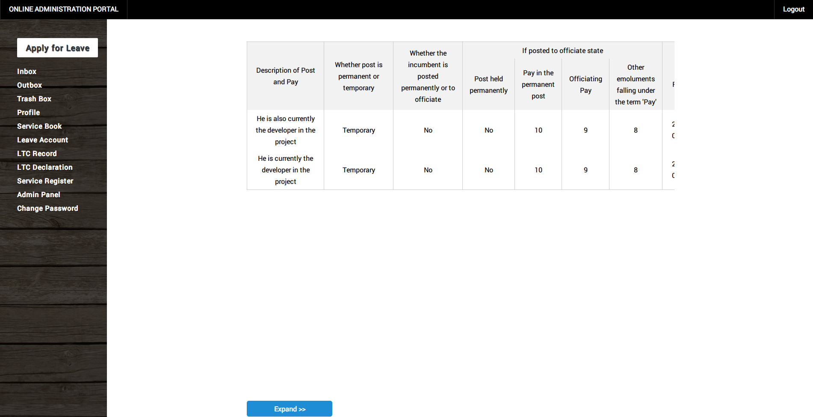

* Click on Expand to see the rest of the table. Click on it again to come back.

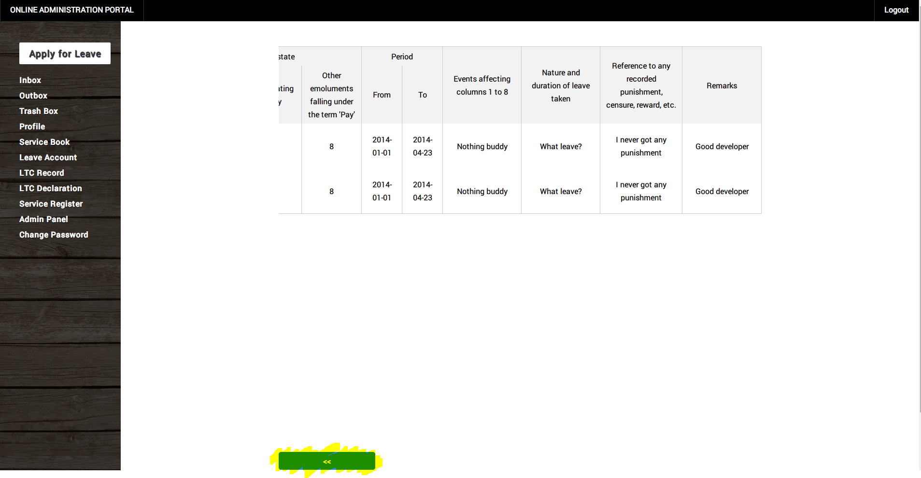

1. Admin Tasks
   1. Admin Panel
      * 1. Register

* Enter the details and press Register to successfully register the person.

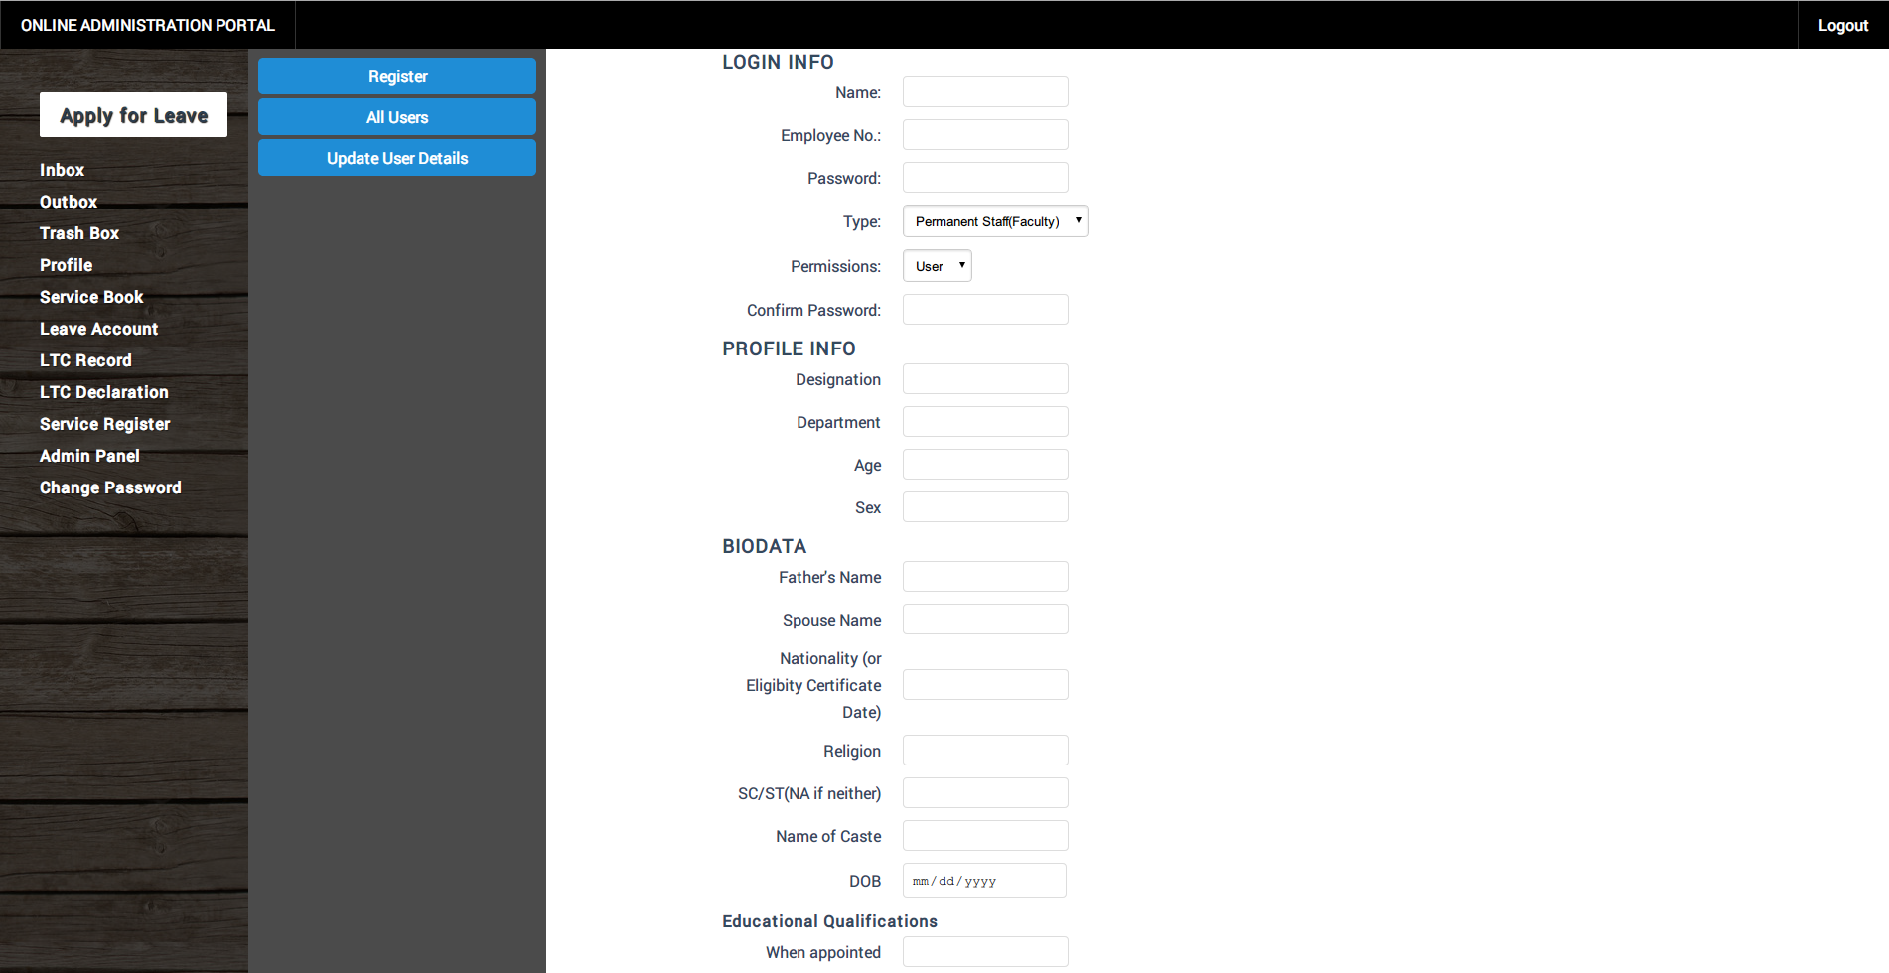

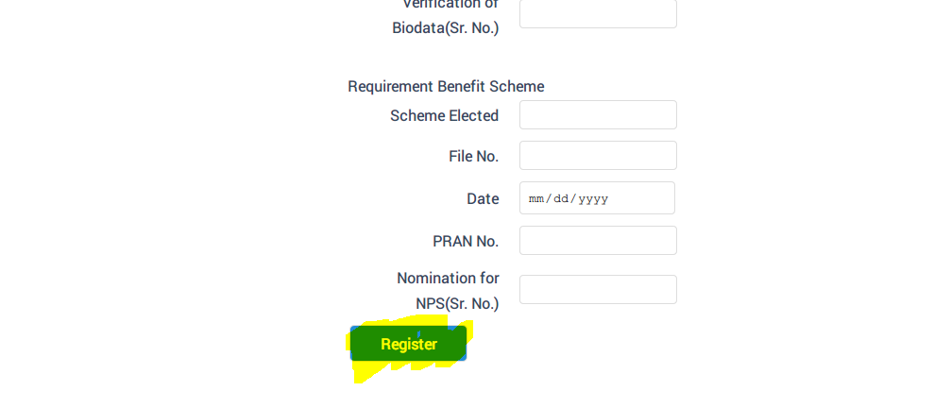

All user details

1. Contains the leave history record of all the users. A table containing the details is displayed.

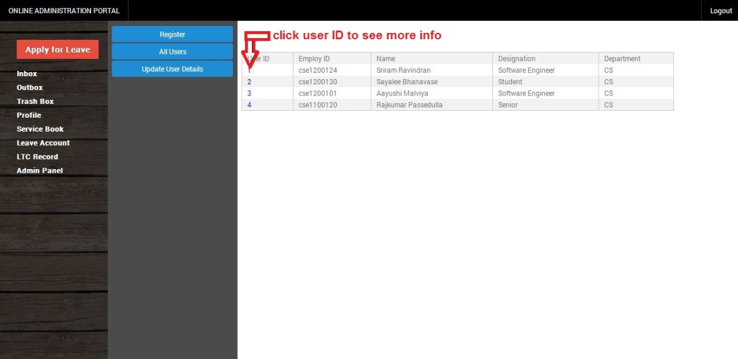

1. Upon clicking any user ID, the leave history of that user is displayed

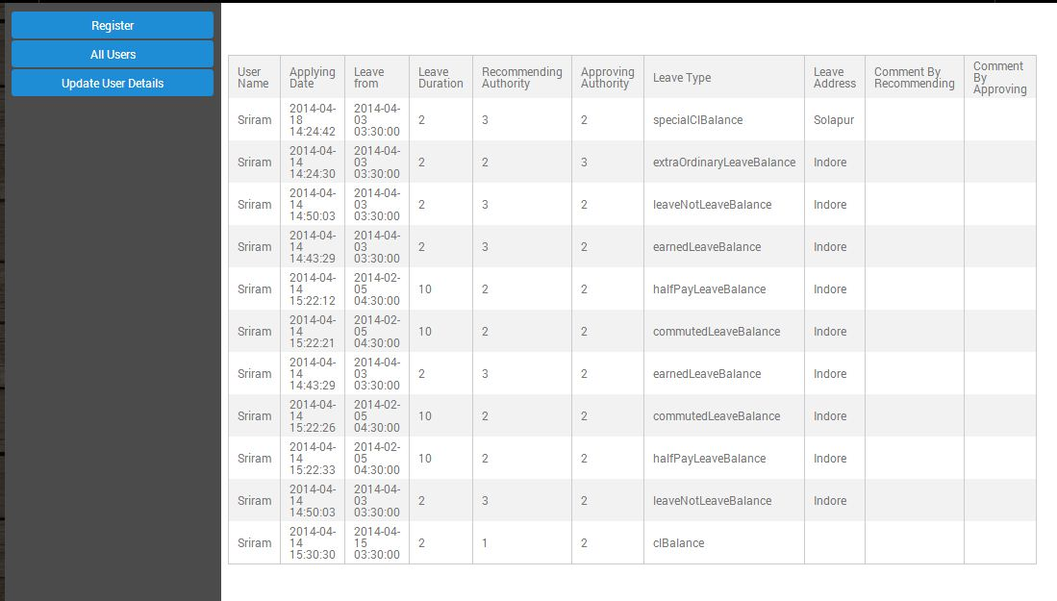

* + - 1. Update user details

5. Logout

Click on the logout button at the top right hand corner in order to logout from the portal.